| Course Name | ITD 2313 – Script Programming |
| --- | --- |
| Instructor | M. Schnell |
| Student Name | Mysam Ata |
| Due date | July 2nd |
| Grade | Put grade earned here |
| Grading Comments | Put instructor comments here |

Pages 165

Project # 1

**Special Instructions:**

1. This project is to be done in a python program file. The file needs to be submitted as part of the submission for this assignment. Place the program file into the zip file that is submitted for this assignment.

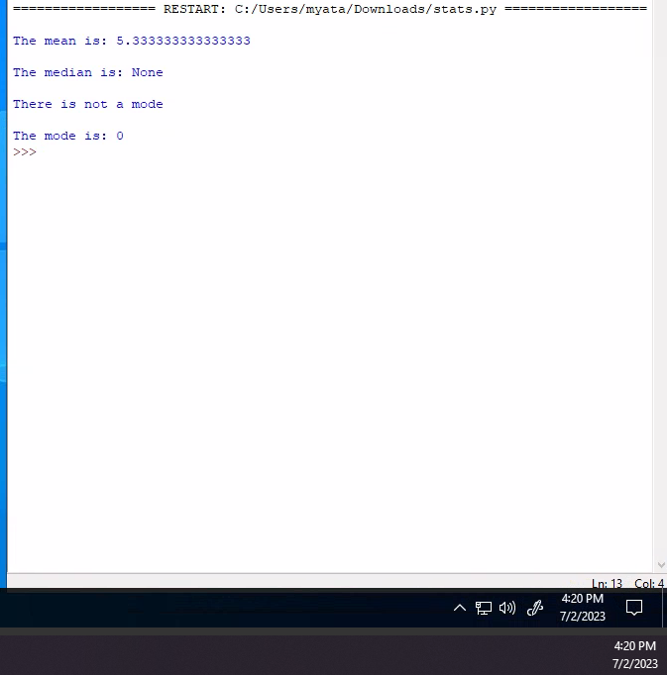

Project # 2

**Special Instructions:**

1. This project is to be done in a python program file. The file needs to be submitted as part of the submission for this assignment. Place the program file into the zip file that is submitted for this assignment.

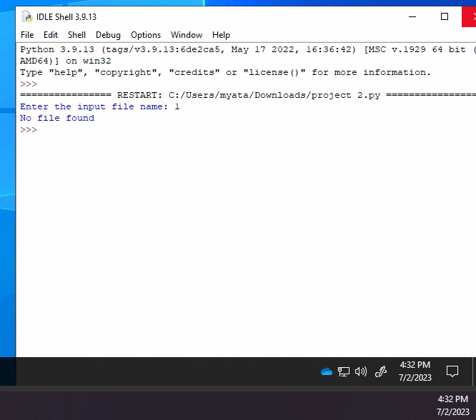

You have made it to the end of this projects assignment. The screen shots you took should be in the Submission document. Any and all code written will need to part of the overall submission to the drop box. Place all code and the submission document into a single ZIP file and submit that zip file to the dropbox.